Heart Disease Risk Prediction
DEPI Final Project - Round 3
September 2025



Contents
1.Team Members 3
2.Project Information 3
3. Project Statement 4
4. Motivation & Objectives 4
4.1 Why these matters 4
4.2 Project goals 5
5. Project stages 5
5.1 Collect Data 5
5.2 Data Understanding: 6
5.2.1 Main Features Description 6
5.2.2 Data information 7
5.2.3 Environment & Dependencies 8
5.2.4 Data Exploration & Preprocessing 8
5.2.5 Feature Engineering 8
5.3 Exploratory Data Analysis (EDA) & Visualization 9
5.4 Solve imbalance 13
5.5 Modeling 14
5.5.1 First Stage: 14
5.5.2 Second Stage: 15
5.5.3 Third stage 16
5.6 Deployment 18

1.Team Members

Name | Phone | Email
Ahmed Hussen Ahmed (Leader) | 01066858421 | ahmedaldonmessi@gmail.com
Menna AbdelGawad Fathi | 01124887979 | mennaabdelgawaad26@gmail.com
Mawada Emad Abdo Omar | 01114559585 | mawadaemad30@gmail.com
Mohammed Ahmed Sayed | 01126933643 | melgayar466@gmail.com
Abdelrahman yasser | 01288217119 | abdelrahmanyr05@gmail.com
rawan | 01158030146 | rawan.ax44@gmail.com

2.Project Information

Dataset | https://www.kaggle.com/datasets/alexteboul/heart-disease-health-indicators-dataset
GitHub Repo | https://github.com/ahmed2005hussen/DEPI_Final_Project
Application | https://depi-final-project.streamlit.app/
Dashboard | https://github.com/ahmed2005hussen/DEPI_Final_Project/blob/main/Heart%20Disease%20Prediction%20Dashboard.pdf
Notebook | https://github.com/ahmed2005hussen/DEPI_Final_Project/blob/main/main.ipynb

3. Project Statement
Heart disease is one of the most common diseases in the world and often leads to death. Many people do not know they have heart disease until they experience a heart attack or stroke. Most people are also unwilling to visit doctors regularly to monitor their health.
However, with the advancement of technology, we can help these people by providing them with a prediction about their health condition without the need to visit a doctor. From home, at any time, they can simply open their phone, answer a few questions, and instantly check their health status.
Since people are naturally worried and always have questions, we also need to integrate a chatbot that can answer their concerns almost like having a private doctor available at any moment.
Our goal is to simplify this process and enable people to check their health status without frequent doctor visits, with no extra cost, no effort, and most importantly, to help them live a healthier life.

4. Motivation & Objectives
4.1 Why these matters
This project will help people take better care of their health.
Benefits include:
- Save lives: Early detection can prevent heart attacks.
- Save money: Prevention is cheaper than treatment.
- Help doctors: Provide healthcare providers with a quick screening tool.
- Easy to use: Accessible to the public.
- High value: Can save people’s lives.
- Recommendation: Chat boot can answer people’s questions.

4.2 Project goals:
- Develop a predictive analytics system to assess patient health risk and provide clear, explainable insights into their medical status.
- Enable personalized healthcare support through recommendations, AI-powered health coaching and lifestyle guidance.
- Support proactive healthcare with the automated health plans, real-time risk classification and preventive recommendations.
- Promote general health awareness by delivering accessible advice for maintaining a healthy lifestyle.

5. Project stages

5.1 Collect Data
This is the first and most important stage. We spent a lot of time searching for a suitable dataset, and eventually we found one that meets our needs. It contains many records, which makes it suitable for training our model and achieving reliable prediction results.
Dataset Source: Kaggle - Heart Disease Health Indicators Dataset.
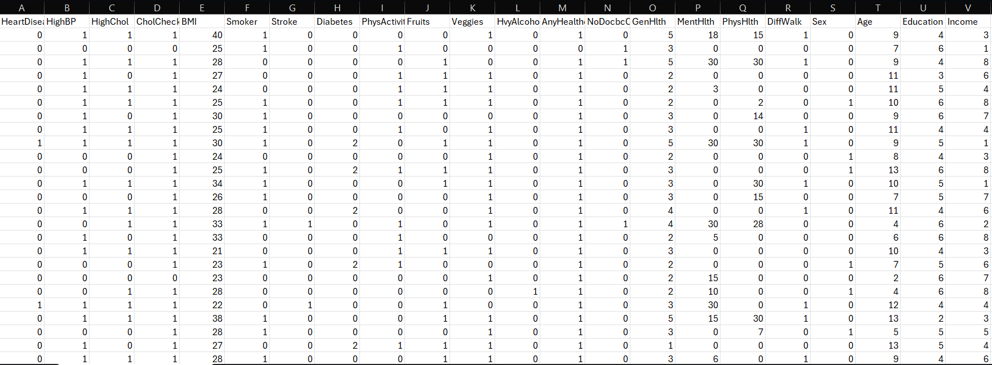

5.2 Data Understanding:
Once we obtain the dataset, we will thoroughly analyze it to understand its structure and content. This includes identifying which features to keep or remove, interpreting the meaning of each value, assessing feature importance for the prediction task, and determining how to preprocess and engineer features to extract useful information.
Key properties: 253680 rows- 22 columns - No missing values - Mix of binary, categorical (age groups), and numeric (BMI) features.

5.2.1 Main Features Description
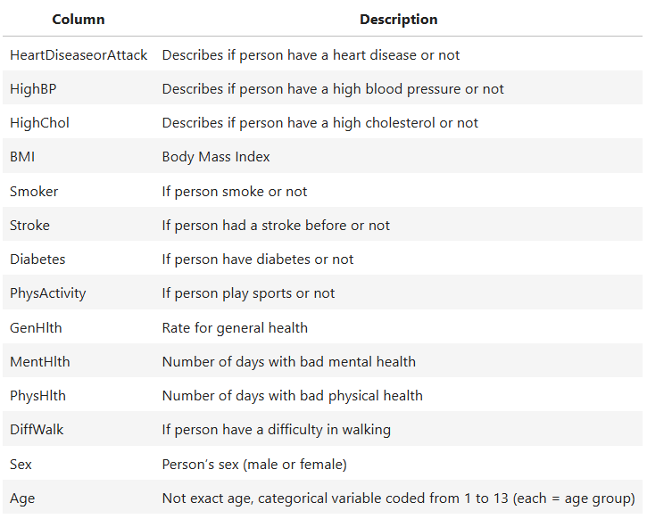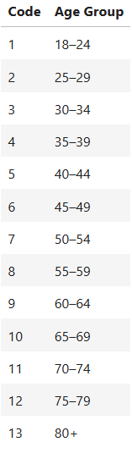

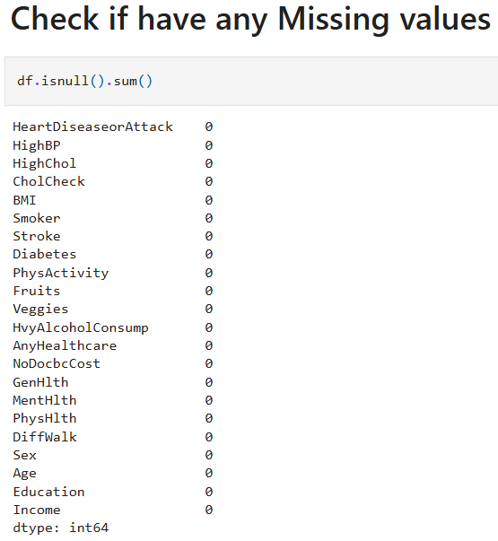
5.2.2 Data information
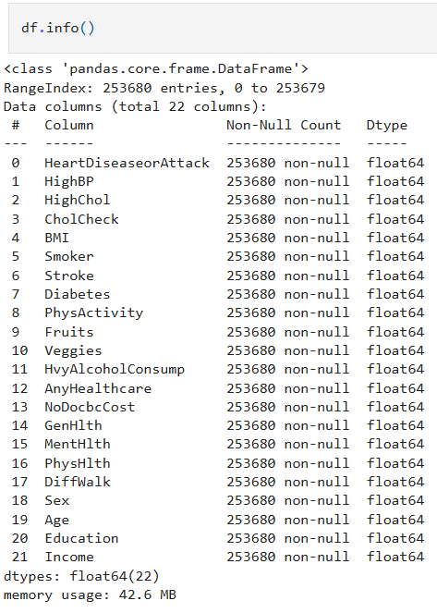

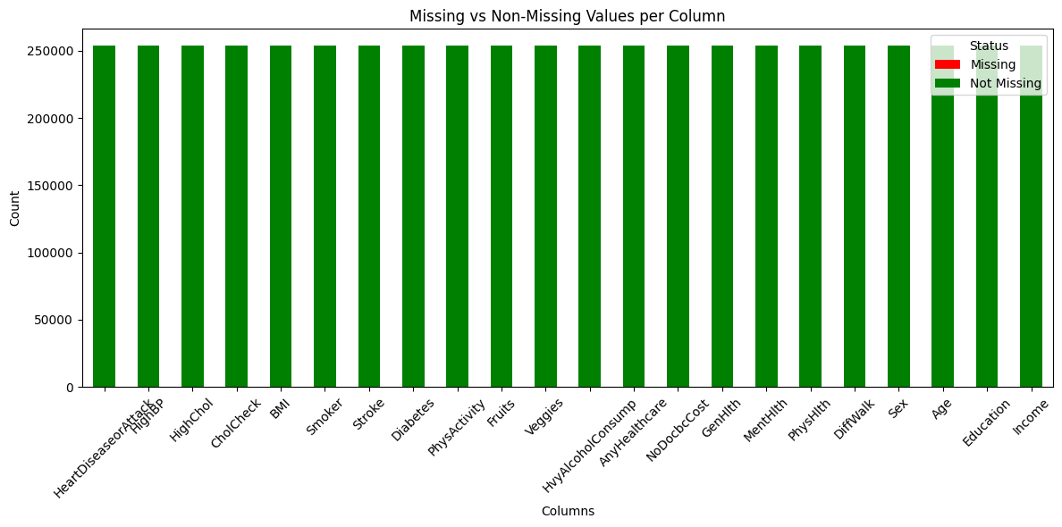
As you see our data is clean, we don’t have null value.

5.2.3 Environment & Dependencies
Primary libraries: - Python- pandas - numpy - matplotlib - seaborn - scikit-learn - imbalanced-learn (SMOTE) - xgboost – joblib – (deployment) streamlit – (chat boot ) Groq

5.2.4 Data Exploration & Preprocessing
Key steps performed:
1. Loaded CSV and printed df.info() and df.describe() to inspect types and distributions.
2. Verified there are no null values: df.isnull().sum() returned zeros for all columns.
3. Investigated duplicates kept duplicates because dataset lacks unique ID and duplicates may represent valid entries.
4. Studied BMI distribution; observed outliers in the upper tail and decided to retain them as medically relevant cases.
5. Converted several binary columns to boolean dtype (e.g., HighBP, Smoker, Diabetes, Sex, HighChol). 6. Removed several non-essential columns and exported the cleaned CSV as Dataset/Train.csv.
Imbalance handling: - The target is imbalanced; applied SMOTE to the training set after the train/test split to balance classes.

5.2.5 Feature Engineering
- Binned BMI into ranges for visualization and exploratory statistics.
- Left Age as an ordered categorical code (1..13) consistent with dataset documentation.
- Considered and removed low-importance features based on feature-importance analysis (e.g., CholCheck, BMI, MentHlth, PhysHlth) in an experimental run to reduce dimensionality.

5.3 Dashboard
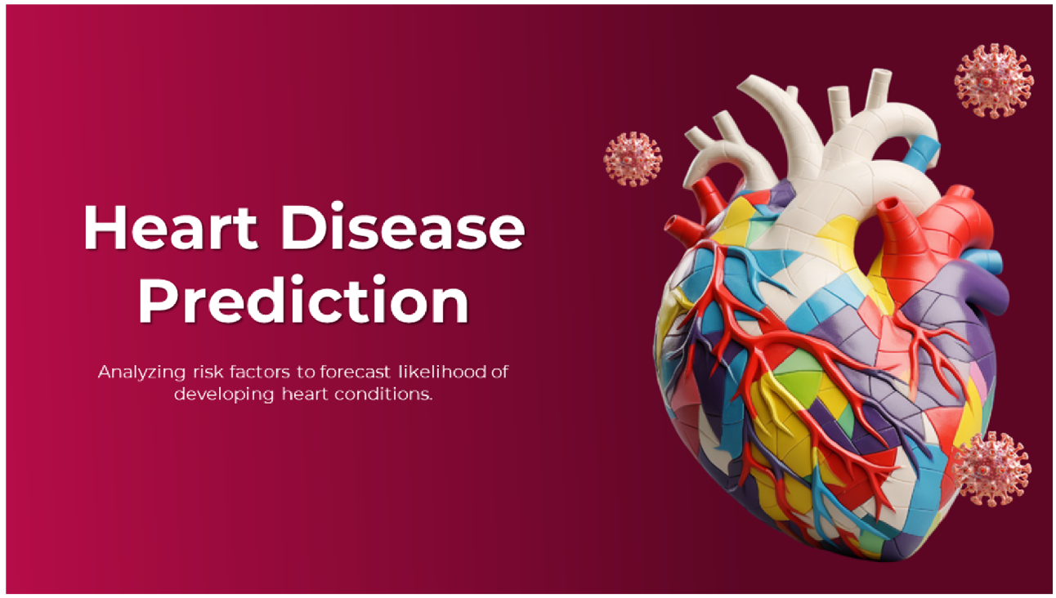
We have a beautiful dashboard to visualize our data.

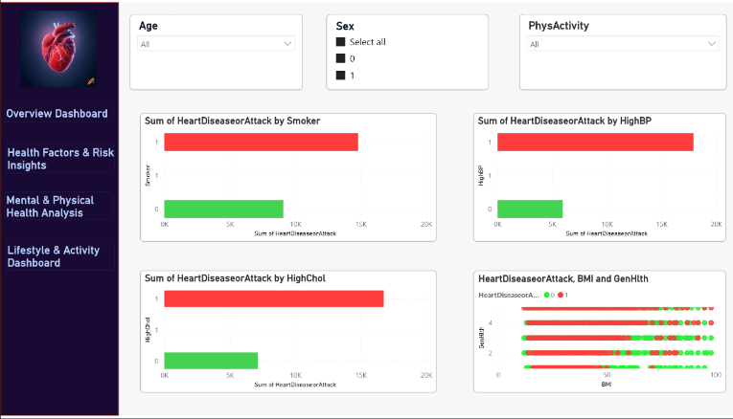
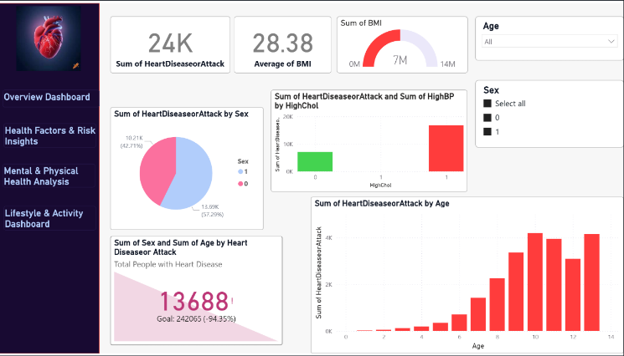

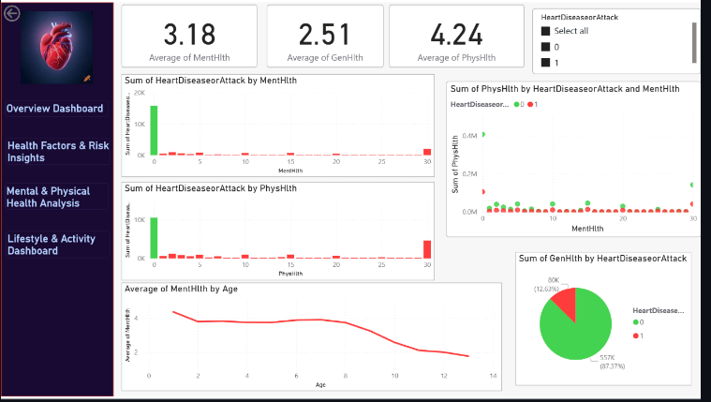
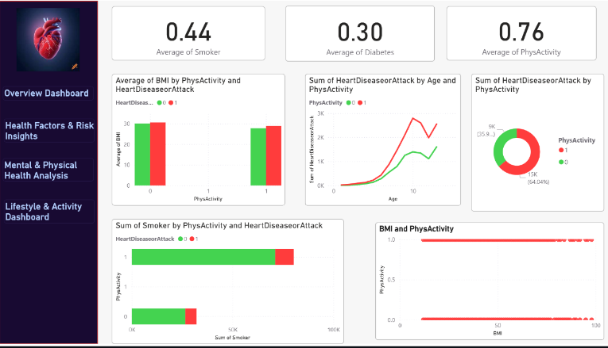

https://github.com/ahmed2005hussen/DEPI_Final_Project/blob/main/Heart%20Disease%20Prediction%20Dashboard.pdf

5.4 Exploratory Data Analysis (EDA) & Visualization
The chart shows that all columns in the dataset have zero missing values Each column has the same count of non-missing records (about 255,000), which means the dataset is complete and consistent with no need for imputation or handling of null values.

Duplicates and unique values
All columns have complete data with no missing values, ensuring dataset reliability for further analysis.
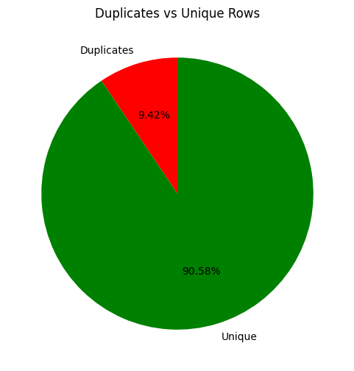
The dataset does not include a unique identifier to distinguish whether records belong to the same individual or different individuals. Therefore, duplicate rows may still represent valid cases and have been retained.
Relation Between BMI and Heart Disease
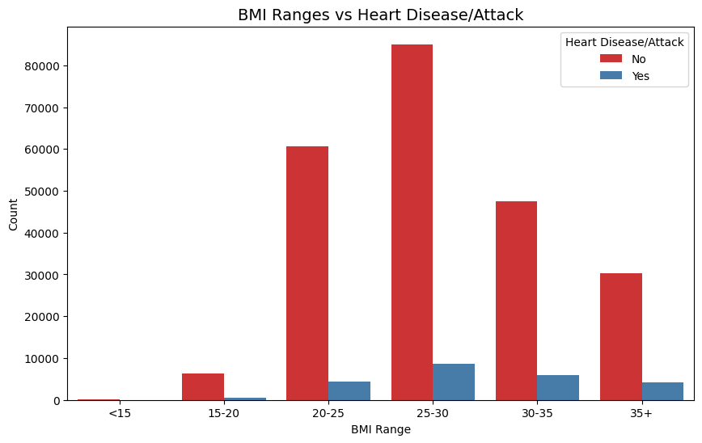
Most individuals fall within the BMI ranges of 20–30. However, the proportion of people with Heart Disease increases noticeably in higher BMI ranges (30+).
This suggests a positive relationship between obesity and the likelihood of heart disease or attack.
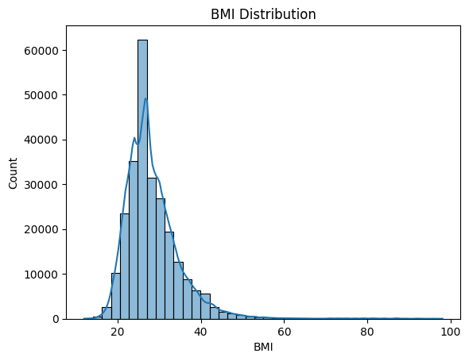
BMI Distribution

Box Plot for BMI
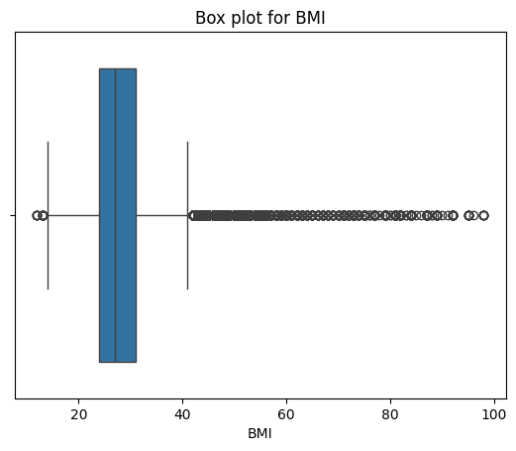
The box plot for BMI shows that while most individuals fall between Q1 ≈ 24 and Q3 ≈ 32, there are many outliers above the upper whisker (~40). These outliers represent individuals with significantly higher BMI values, and they are important to retain since they capture cases of severe obesity, which are strongly linked to health risks such as heart disease, diabetes, and high blood pressure.
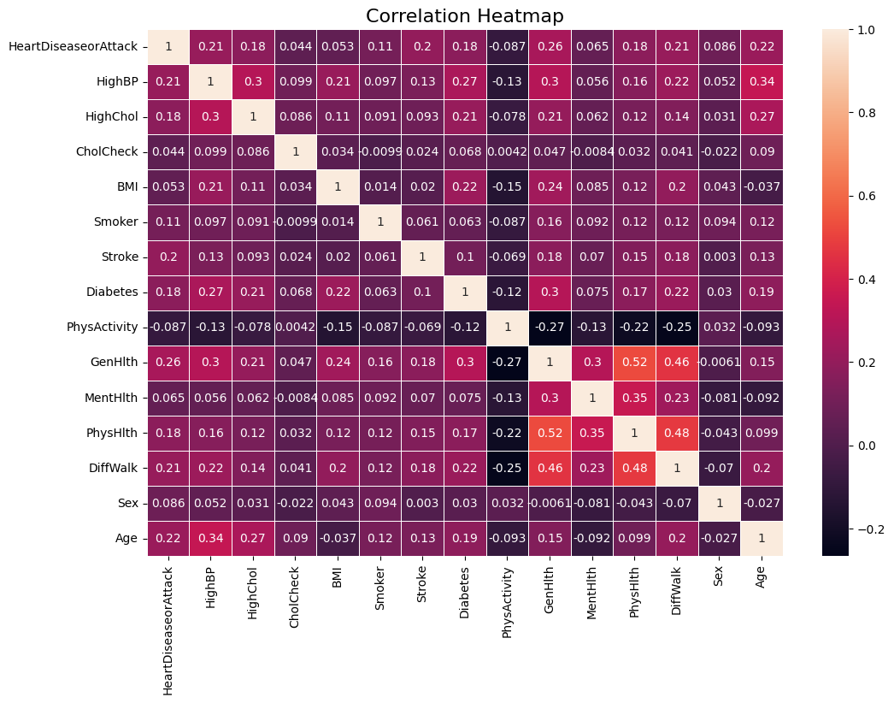
Correlation

Correlation with the target:

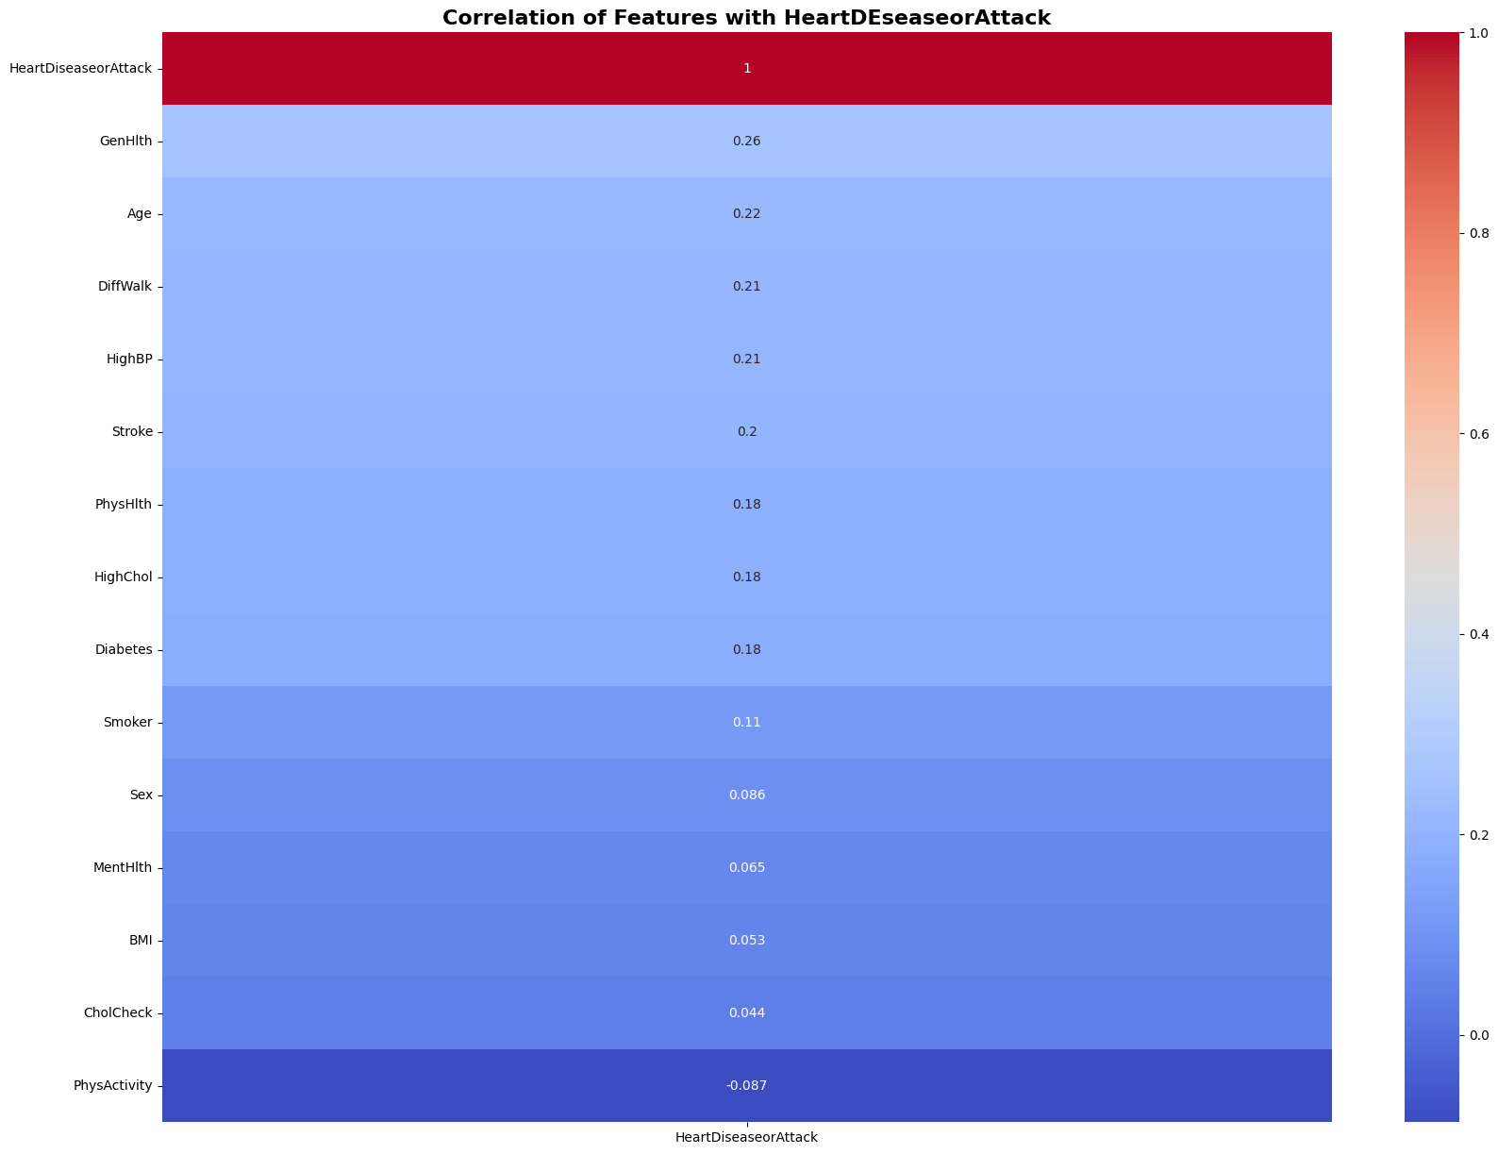

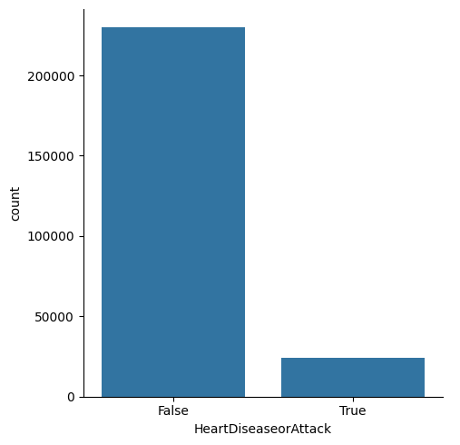
Count HeartDissesorAttack:

This indicates that our dataset is imbalanced,
which needs to be addressed before building the model.

Heart Disease with Smokers:

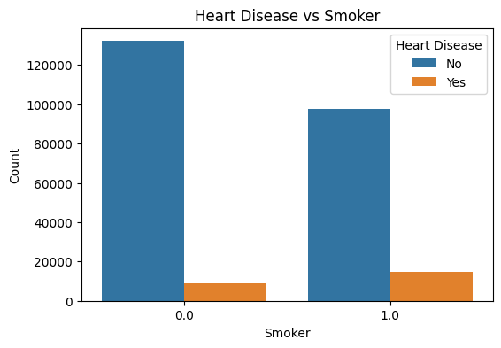
Smoking appears to be a risk factor for heart disease in your dataset. While the absolute number of heart disease cases is smaller than non-cases, smokers have a higher relative proportion of heart disease than non-smokers.

5.5 Solve imbalance
Before modeling we need to solve the imbalance in our data, to avoid overfitting.
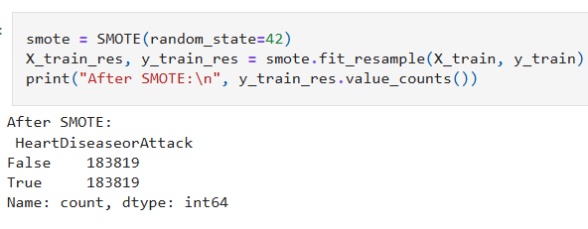
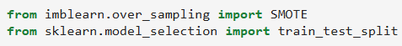
We used SMOTE to solve the imbalance:
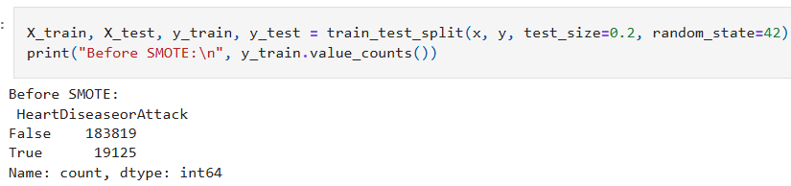
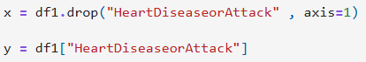

5.6 Modeling
We chose the XGBoost classifier for our project because it is known for its high accuracy, efficiency, and strong performance in classification tasks. XGBoost handles large datasets effectively and captures complex patterns in the data, which is essential for predicting heart disease. It also includes regularization techniques that reduce overfitting, making the model more reliable. Additionally, XGBoost can deal with missing values automatically and provides useful insights into feature importance, helping us understand which factors have the greatest impact on the prediction.

Before reaching the final model, we passed through three major improvement stages. Each stage focused on enhancing a specific aspect of the model, such as data quality, feature selection, and parameter optimization. The following section explains each stage in detail.

5.6.1 First Stage:
In the first stage, we trained a basic XGBoost classifier using default parameters to establish an initial performance baseline. The model achieved an accuracy of 84.64%, with strong performance on healthy cases but weaker detection of heart disease cases.
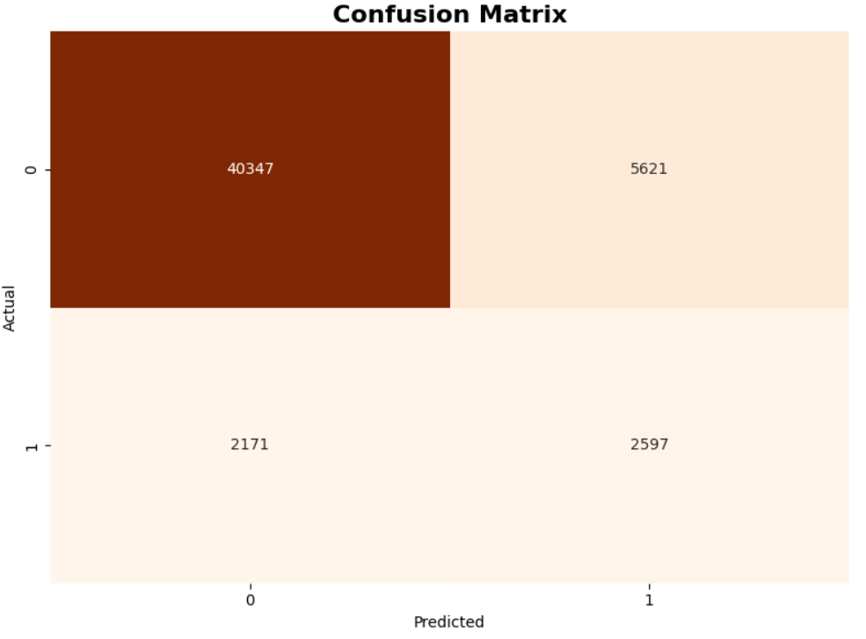
The confusion matrix shows that the model correctly identified 2,597 patients but missed 2,171 (false negatives). It also produced 5,621 false positives, indicating a trade-off between sensitivity and specificity. Overall, this stage highlighted the need for further improvement to enhance the model’s ability to detect true heart disease cases more accurately. And that’s meaning the model say “2171 is healthy“, but the truth they not. For this we need to reduce this number

5.6.2 Second Stage:
In the second stage, we focused on improving the model’s recall for heart disease cases. Several hyperparameters were adjusted, including increasing the number of trees, reducing the learning rate, increasing model depth, adding subsampling, and applying class weighting with scale_pos_weight=10 to emphasize the minority class.
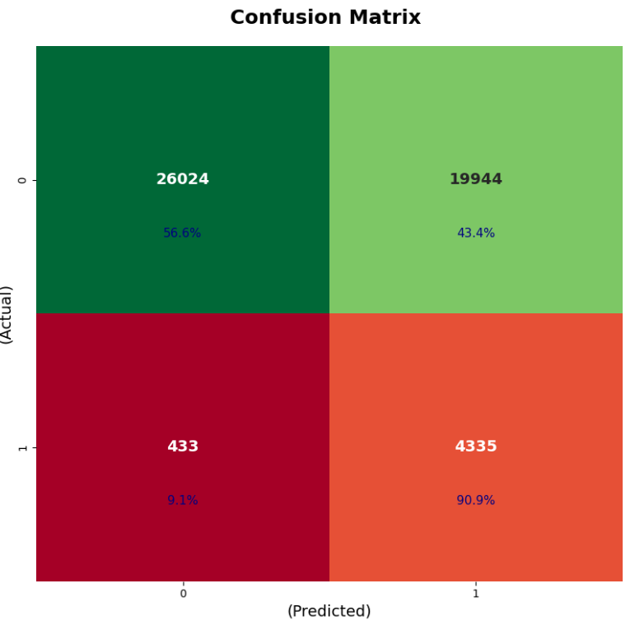
The confusion matrix shows that the model correctly identified 4,335 out of 4,768 patients while missing only 433 (a major improvement in patient safety).
However, this improvement came with a trade-off: accuracy dropped to 59.84%, and the number of false positives increased sharply (19,944 healthy individuals incorrectly flagged as at-risk). Despite this decrease in overall accuracy, the model successfully achieved the primary medical objective of minimizing missed heart disease cases.
Our goal is to discover the patient, the model now say to 433 patients you are healthy but they are not, but if you see the number now is less than the first stage, and this is good.

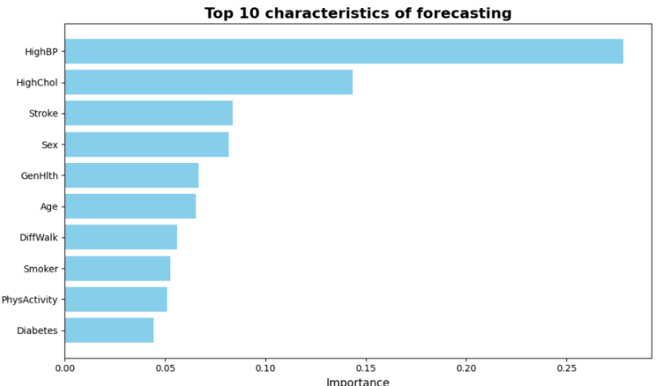
Feature Importance
This is the top characteristics of forecasting so we can use it only for our model and see if the result is good.

5.6.3 Third stage
In the third stage, we focused on strengthening the model’s ability to detect heart disease cases by giving more attention to the minority class. To achieve this, several improvements were introduced before retraining the model. These included increasing the number of estimators, reducing the learning rate for more stable learning, increasing model depth, applying subsampling, and using class weighting with scale_pos_weight=10.
Additionally, we used SMOTE to oversample the minority class, giving the model a balanced and representative training set.
After applying these enhancements, we retrained the model on the updated dataset and evaluated its performance on the test set.



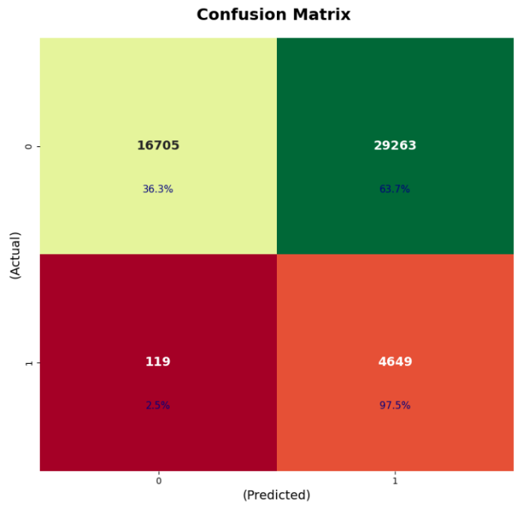
Performance Evaluation

The confusion matrix shows that the model successfully identified 4,649 out of 4,768 true patients, missing only 119 cases. This represents a strong improvement in patient safety, as the number of missed cases is now significantly lower compared to previous stages.
However, this improvement came with a trade-off: the number of false positives increased (29,263 healthy individuals incorrectly classified as at-risk), leading to a drop in overall accuracy to 42.09%.
Even with this drop, the model achieved its most critical medical objective minimizing false negatives and ensuring that nearly all positive cases are detected.
Our priority is to discover every potential patient. The model now misclassifies only 119 true cases as healthy, which is much lower than in earlier stages, and this is a positive and important step toward building a reliable early-warning system.
And this is our last model.

5.7 Deployment
We use streamlit to deploy our model.
Link: https://depi-final-project.streamlit.app/
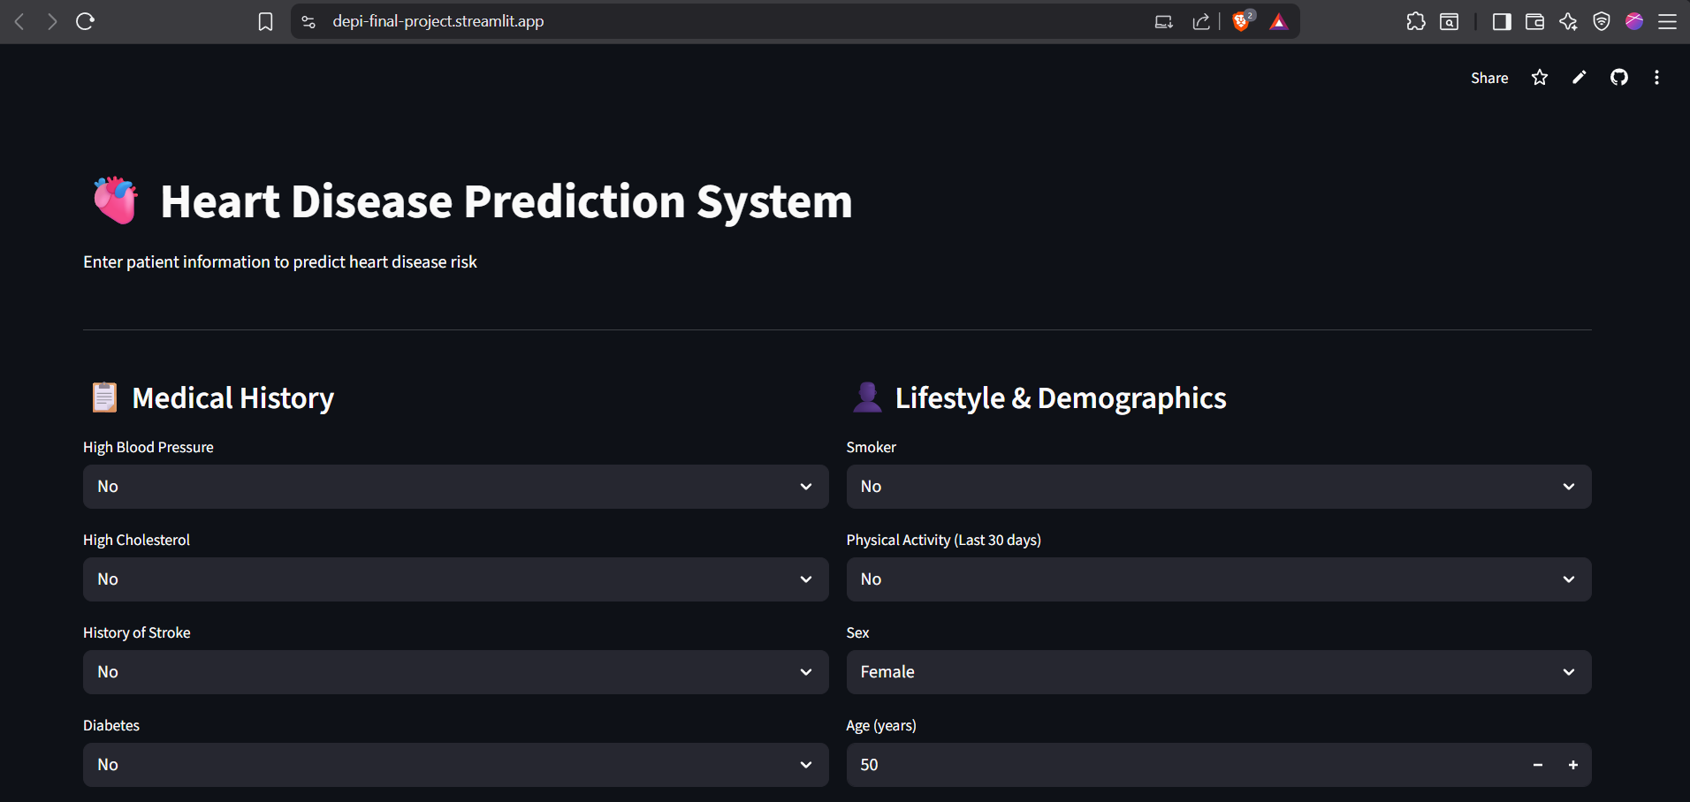
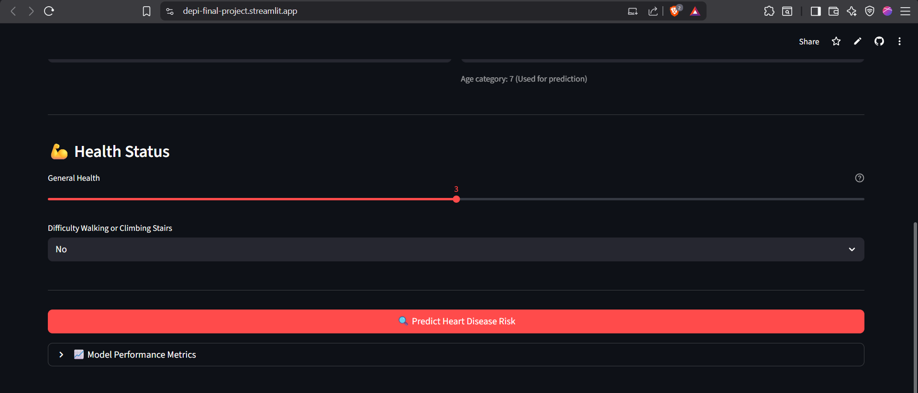
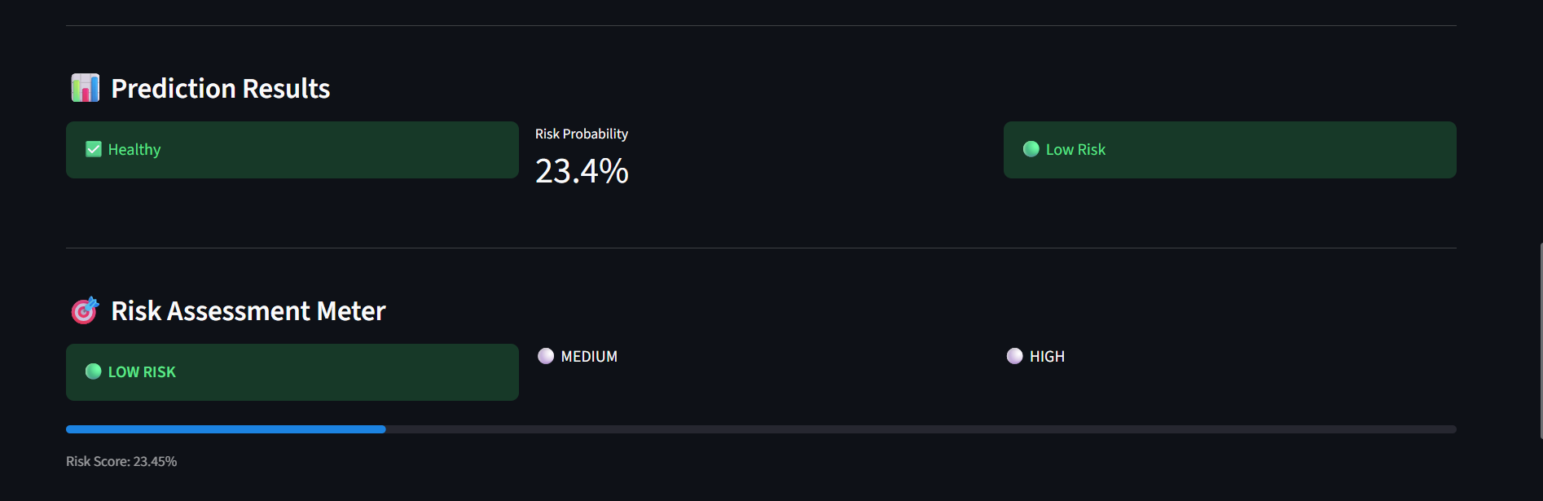
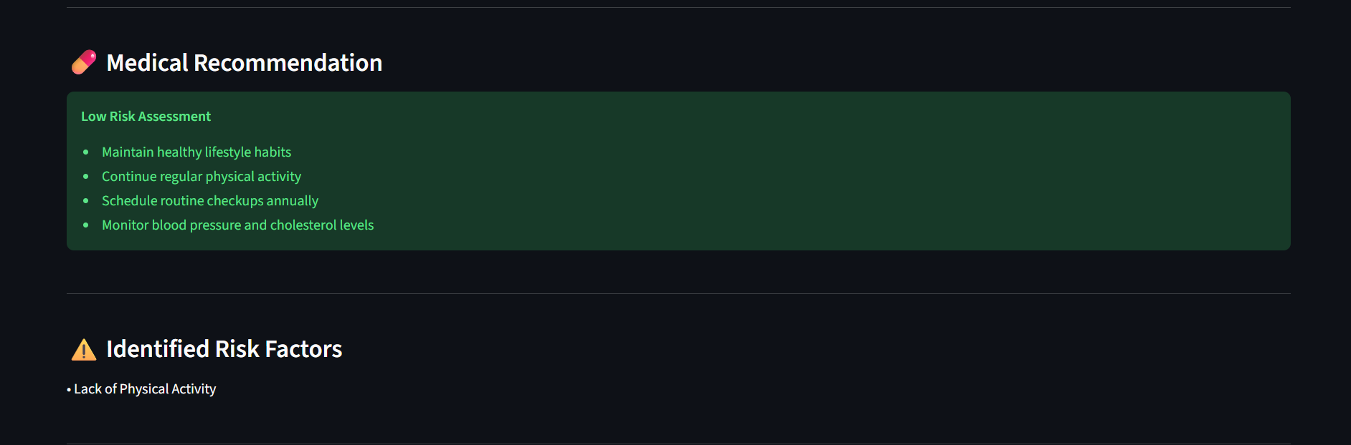
Chat boot
